BIT 4107 – Mobile Application Development
ENHANCED PROFESSIONAL STUDENT LOGBOOK
Student Name: LINA MUKUNDI
Admission Number: BIT/2025/58773
School/Faculty: COMPUTING AND INFORMATICS
Programme: BACHELOR’S OF SCIENCE IN INFORMATION TECHNOLOGY
Academic Year: 2026/2027
Semester:
Lecturer: MR NYORO
Phone Number: 0705923130

Week 1: Introduction to Mobile Application Development

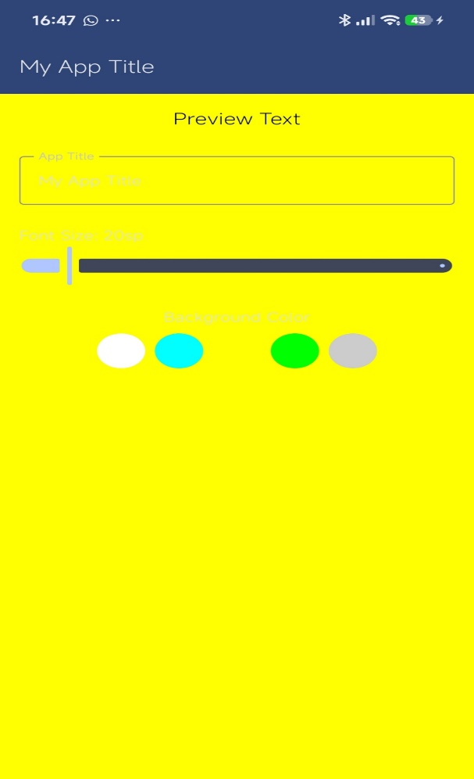
The is color change

Tools/Software Used
- Android studio
- Sdk tools
- Gemini

Personal Reflection
- • When the user increases the font size to its maximum level, the title text may become clipped. To prevent this issue, text constraints should be implemented within the preview area.
- This project demonstrates the importance of designing decoupled user interface components, as the top panel operates independently from the rest of the application.
- The project also emphasizes the value of intuitive user experience (UX) design by integrating multiple input methods, thereby reducing the user's cognitive load and improving overall usability

Week 2: Mobile Development Environment

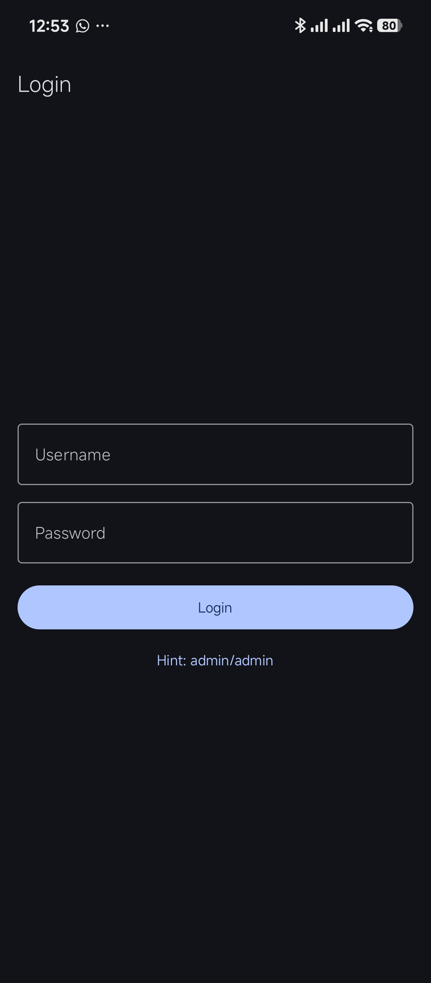
The user will input the login details
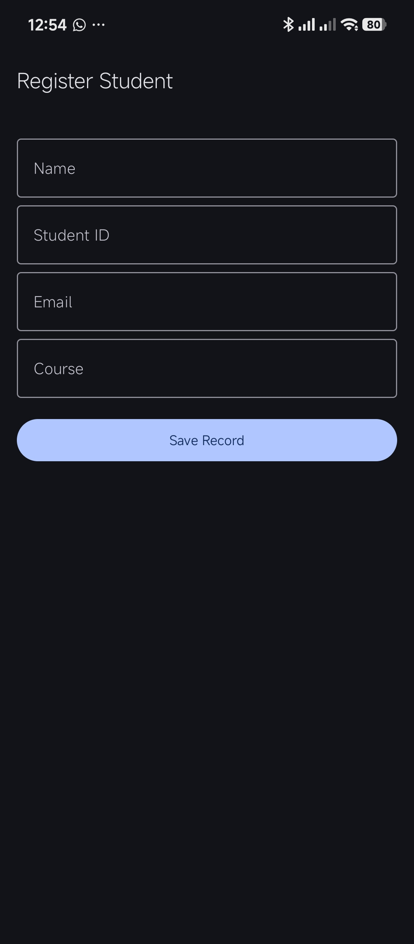
The student details are registered
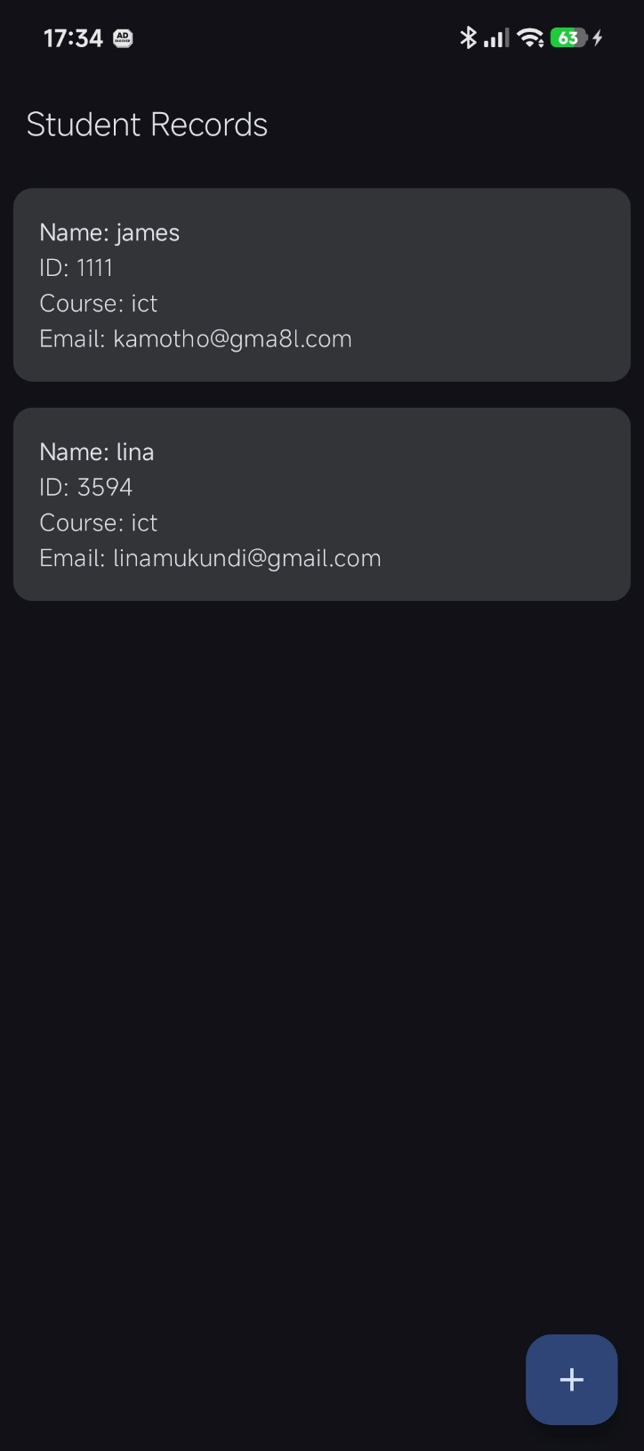
The stored record
Tools/software used
- Android studio
- SDK components
- Gemini
Personal Reflection
- The core architecture used for capturing user inputs, storing data, retrieving records, and implementing security controls forms a fundamental framework that is widely applied in commercial and enterprise applications.
- Maintaining consistency in the UI/UX design contributes significantly to the overall user experience. The uniform use of dark-themed backgrounds creates a cohesive, professional, and visually appealing interface.

Week 3: User Interface Design
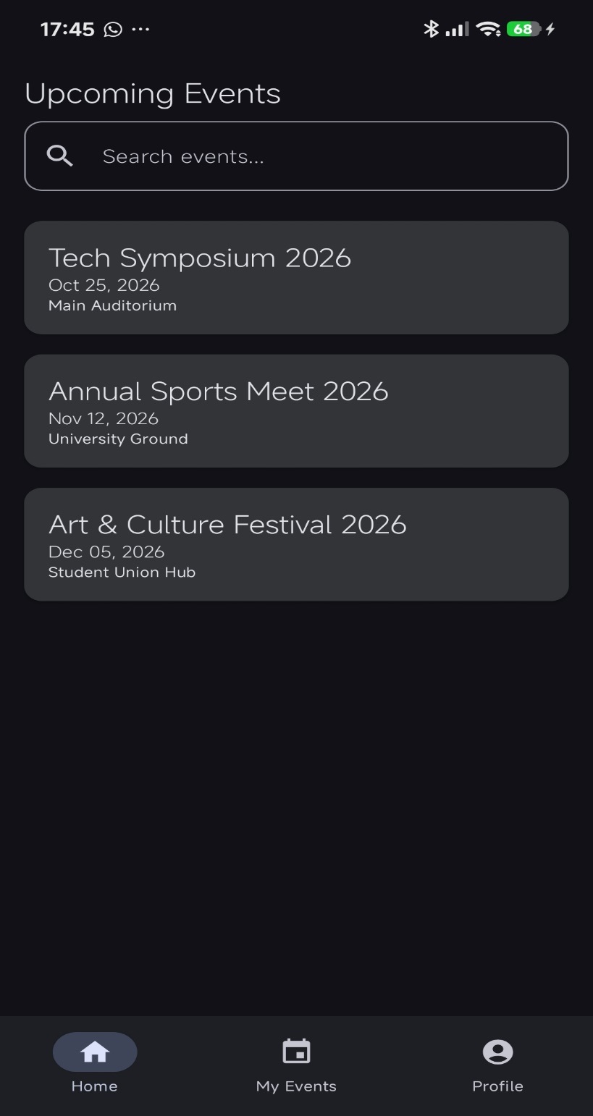
Tools/software used
One can schedule events, view profile
- Android studio
- SDK components
- Gemini
- • Improved my understanding of mobile application UI/UX design principles.
Personal Reflection
- Enhanced my skills in creating responsive and user-friendly interfaces.
- Learned how to implement effective screen navigation and functional forms.
- Gained practical experience in prototyping using Figma and mobile development frameworks.
- Understood the importance of Git and GitHub for version control and collaboration.
- Developed awareness of Firebase services, API integration, and real-world application development.
- Appreciated the role of agile methodologies, task management, and project planning in software development.

Week 4: Event Handling and User Interaction

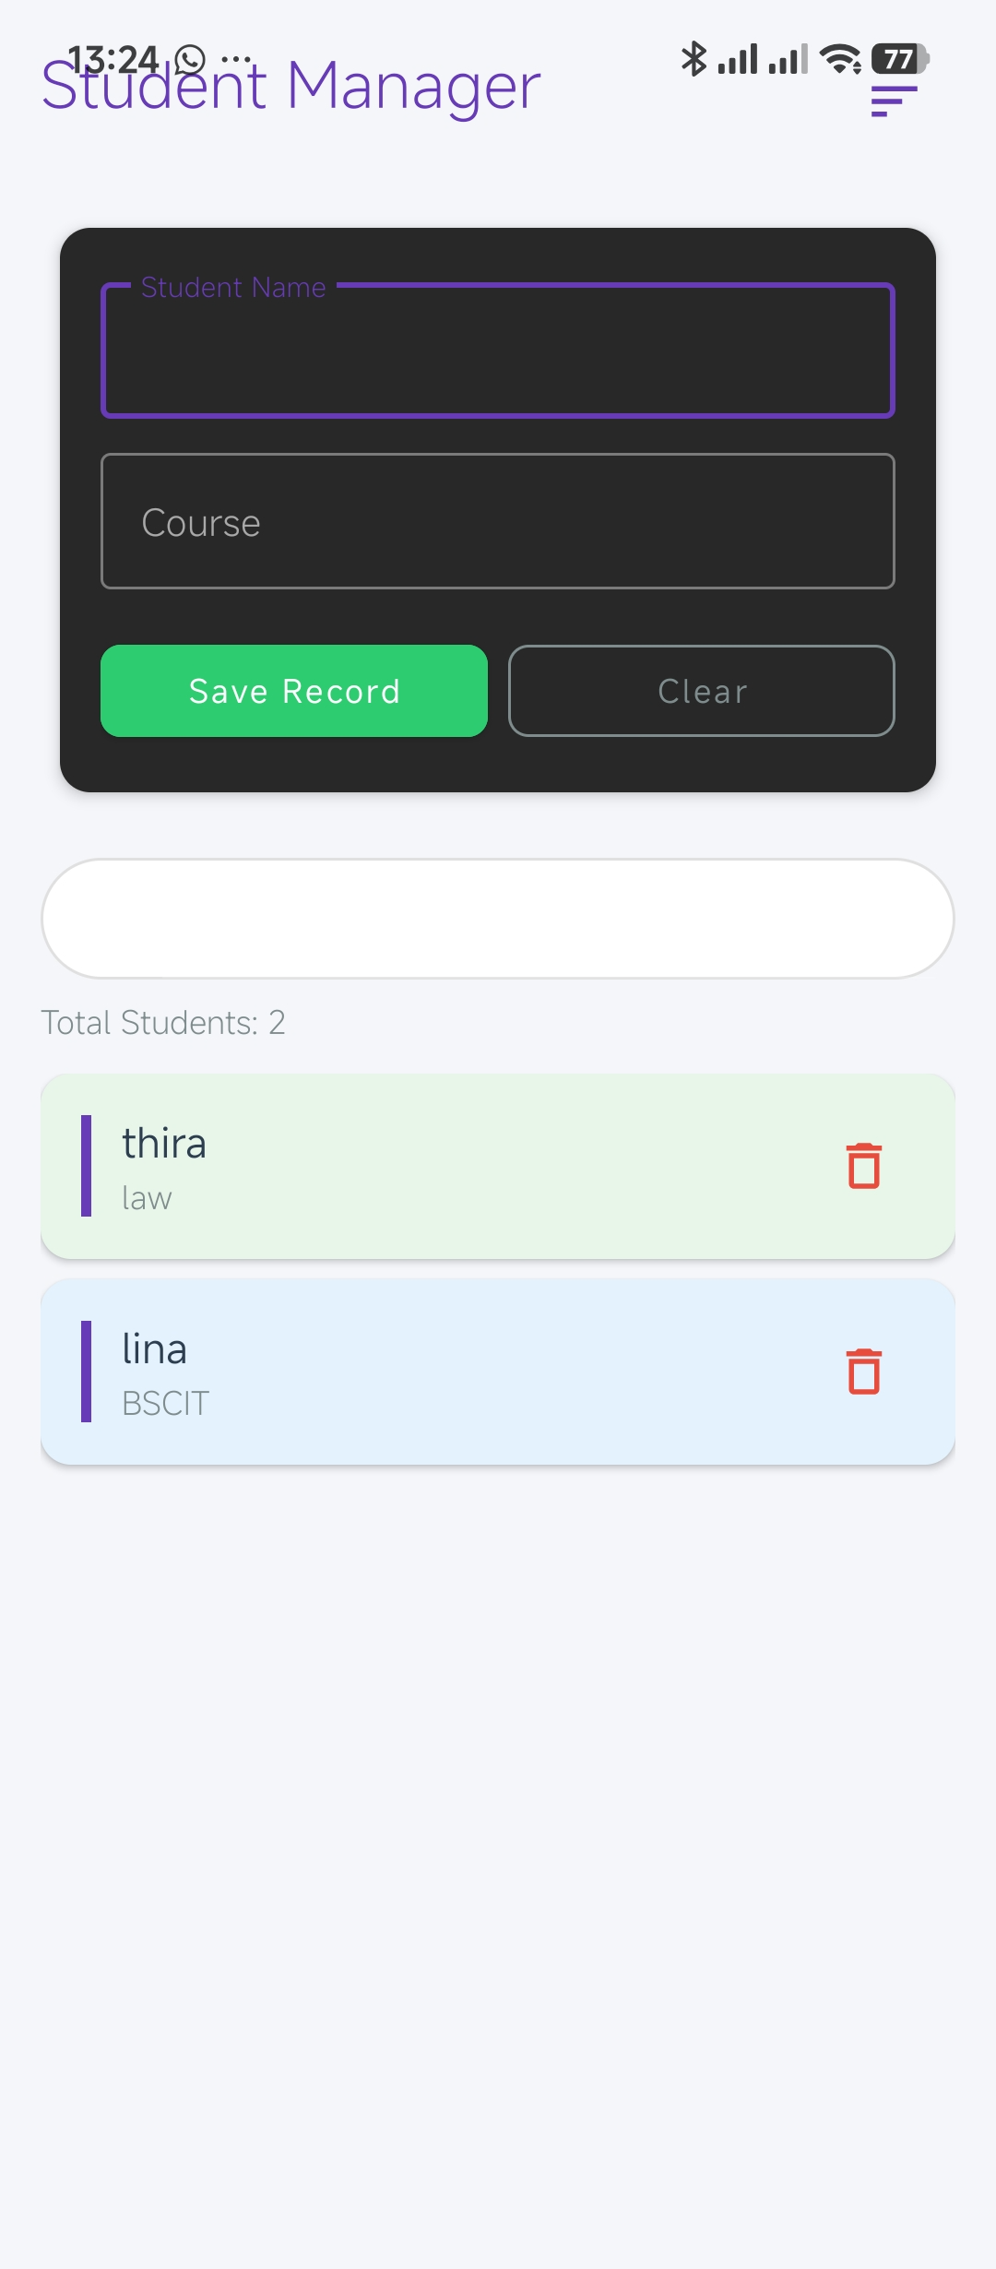
Tools/software used
- Android studio
- SDK components
- Gemini
Personal Reflection
Because the delete (trash bin) icon is positioned within each scrollable list item, users may accidentally tap it while navigating through records on their mobile devices. This can result in the unintended removal of valid employee data. Although careful use of the application helps minimize such errors, incorporating a confirmation prompt before deletion would improve reliability and prevent accidental data loss.

Week 5: Data Management
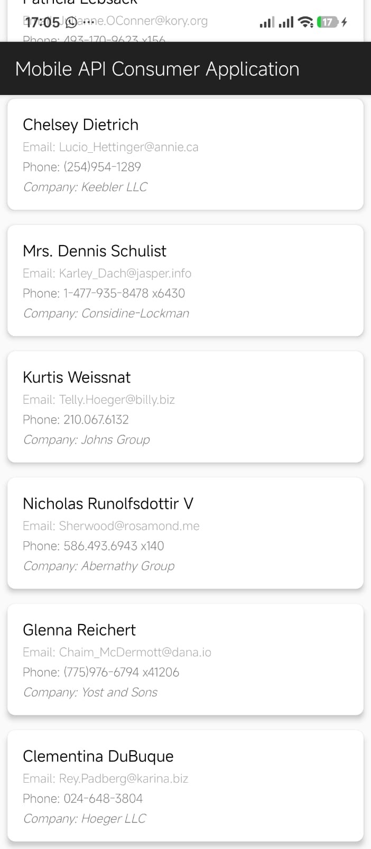
Tools/software used
- Android studio
- SDK components
- Gemini
Personal Reflection
This screen represents a shift from purely local mobile development to full-stack, connected application design. By integrating live data from a remote server into the existing UI components, the project effectively connects native interface design with cloud-based services. The application successfully interacts with web APIs, and its architecture provides a strong foundation for more advanced cloud-driven features.

Week 6: Networking and APIs

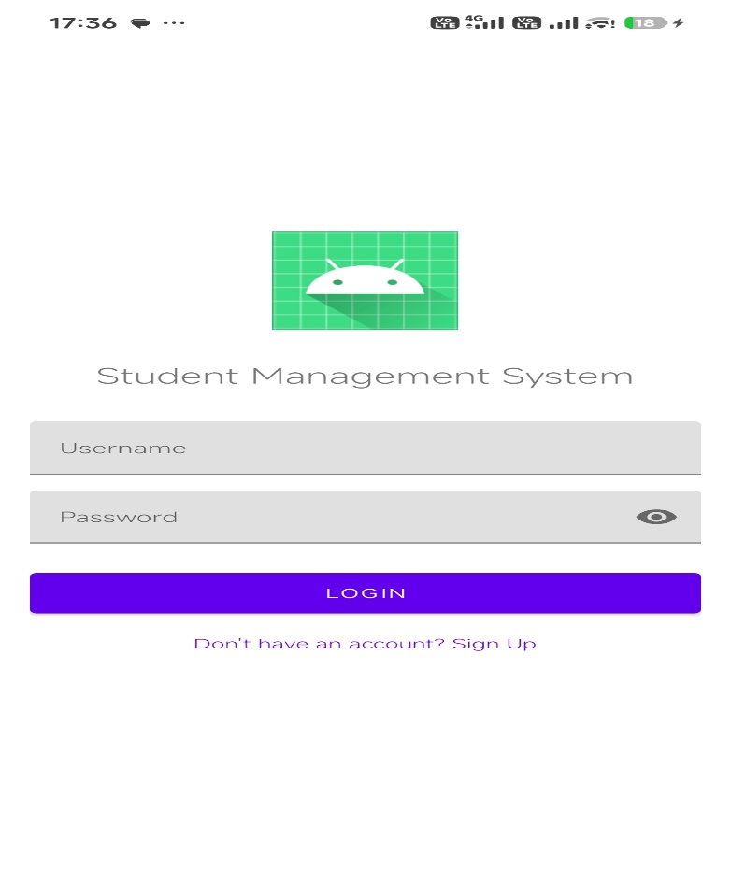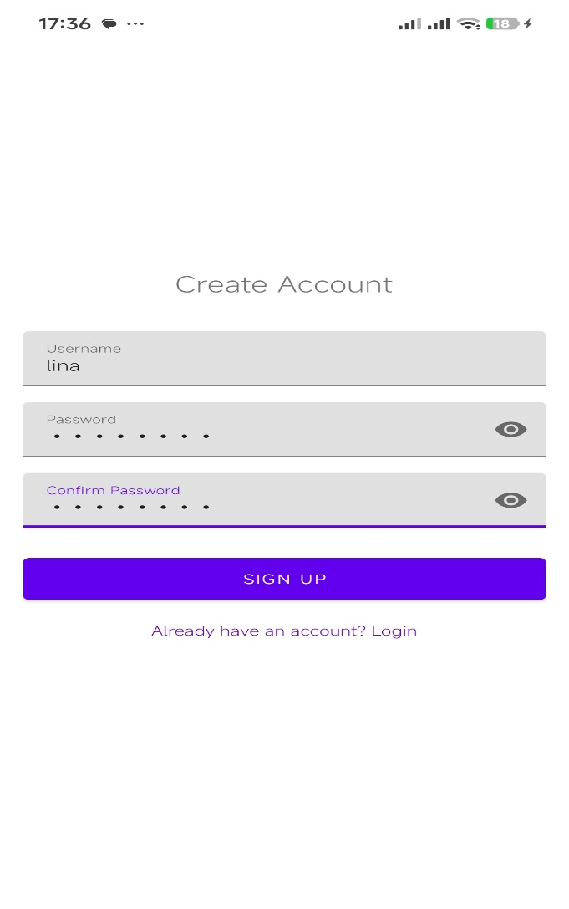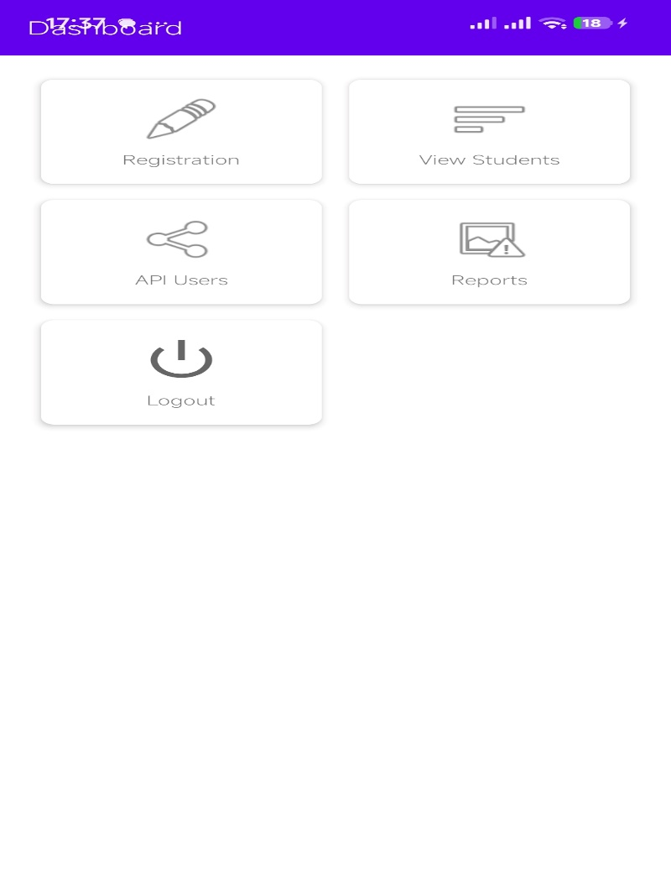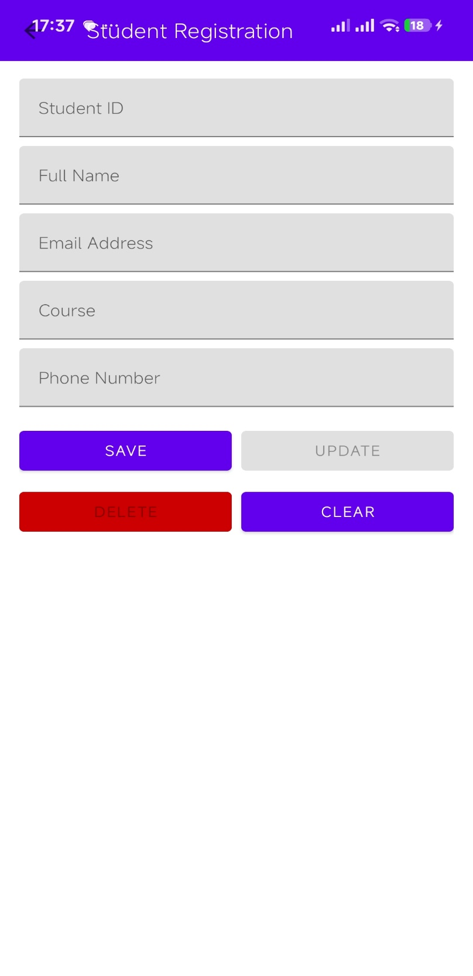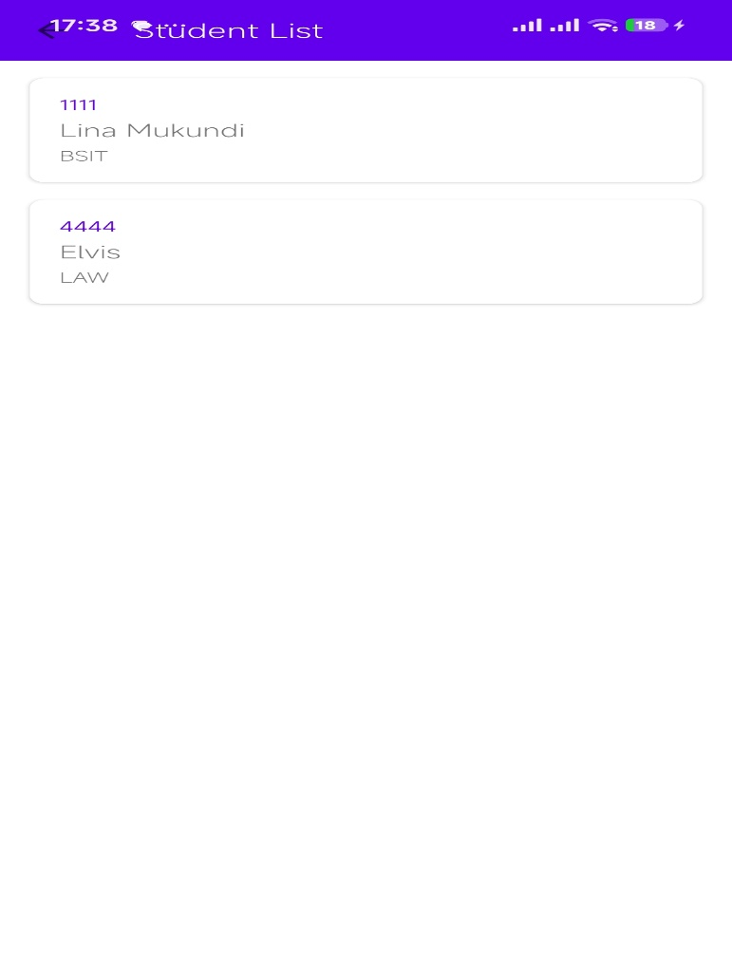
The user can login or signup if they do not have an account
They create a user account
Here you add the student details and update save and can clear the details
This shows the list of students in the database
Tools used
- Gemini
- Android studio
- Sdk tools
personal reflection
- This work helped me understand how to build a complete mobile app by combining UI design, navigation, SQLite database, and API integration into one system.
- I improved my practical Android development skills, especially in handling data storage, networking, and error management in real applications.

Week 7: Application Architecture
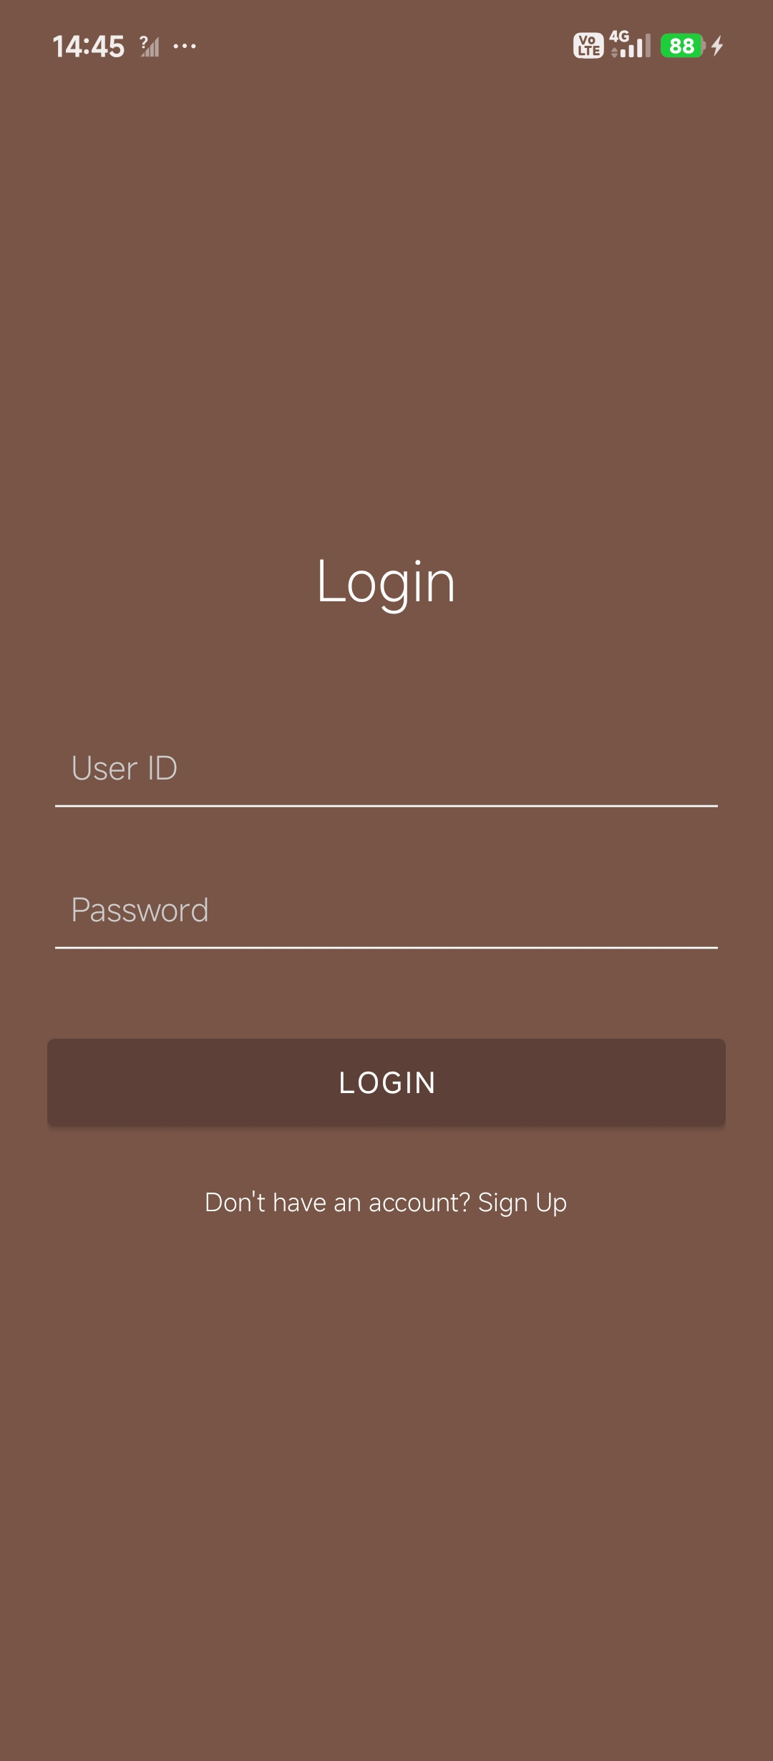
The user can log in or sign up if they do not have an account
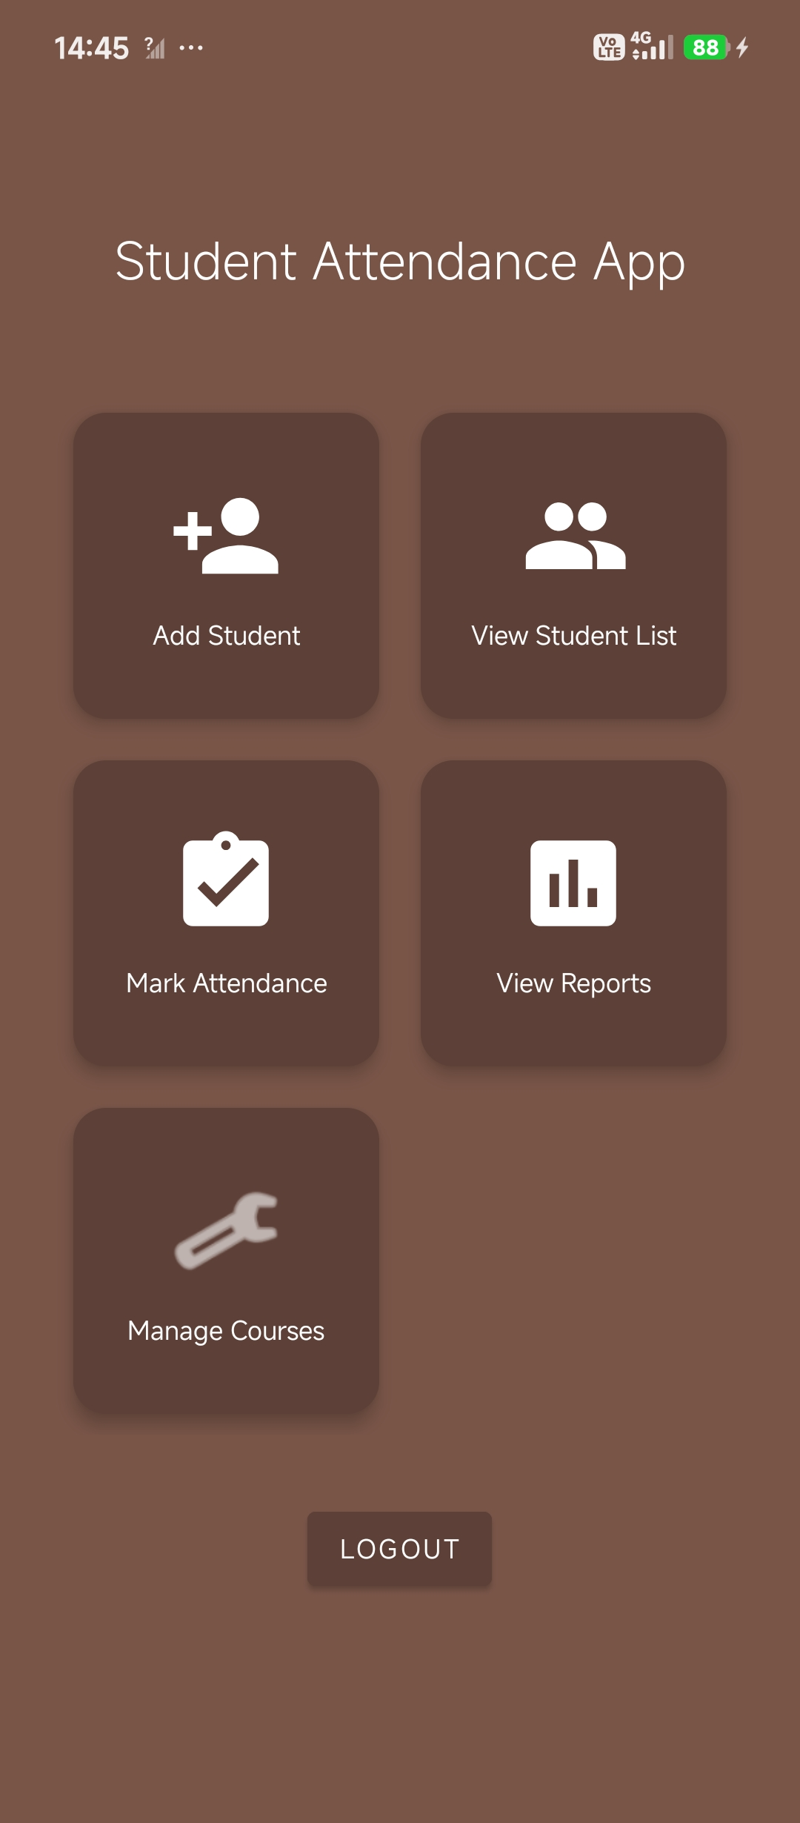
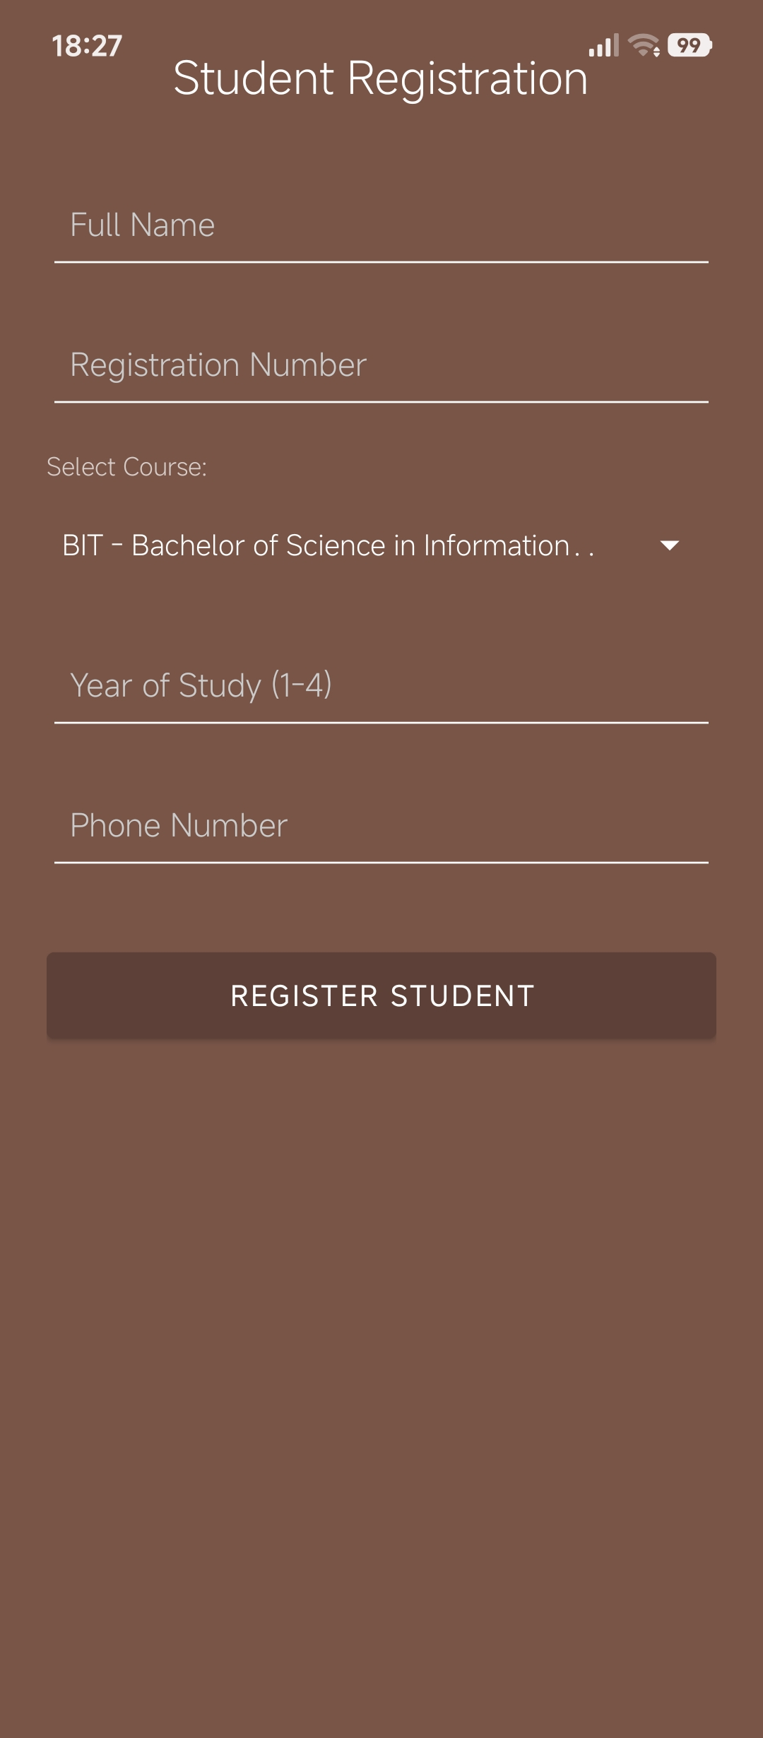
The student’s details are registered in the database. One can select the course name
The stored student’s details
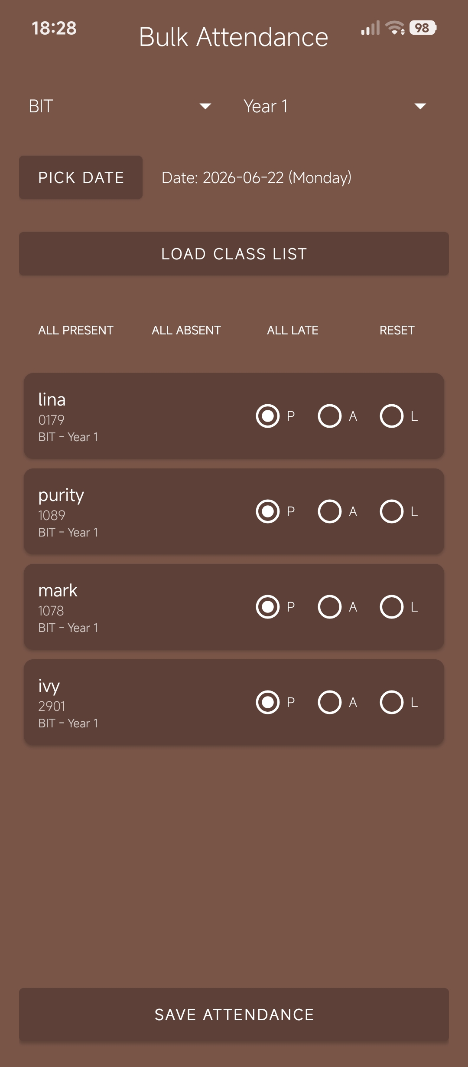
The student’s attendance is recorded by clicking whether present absent or late
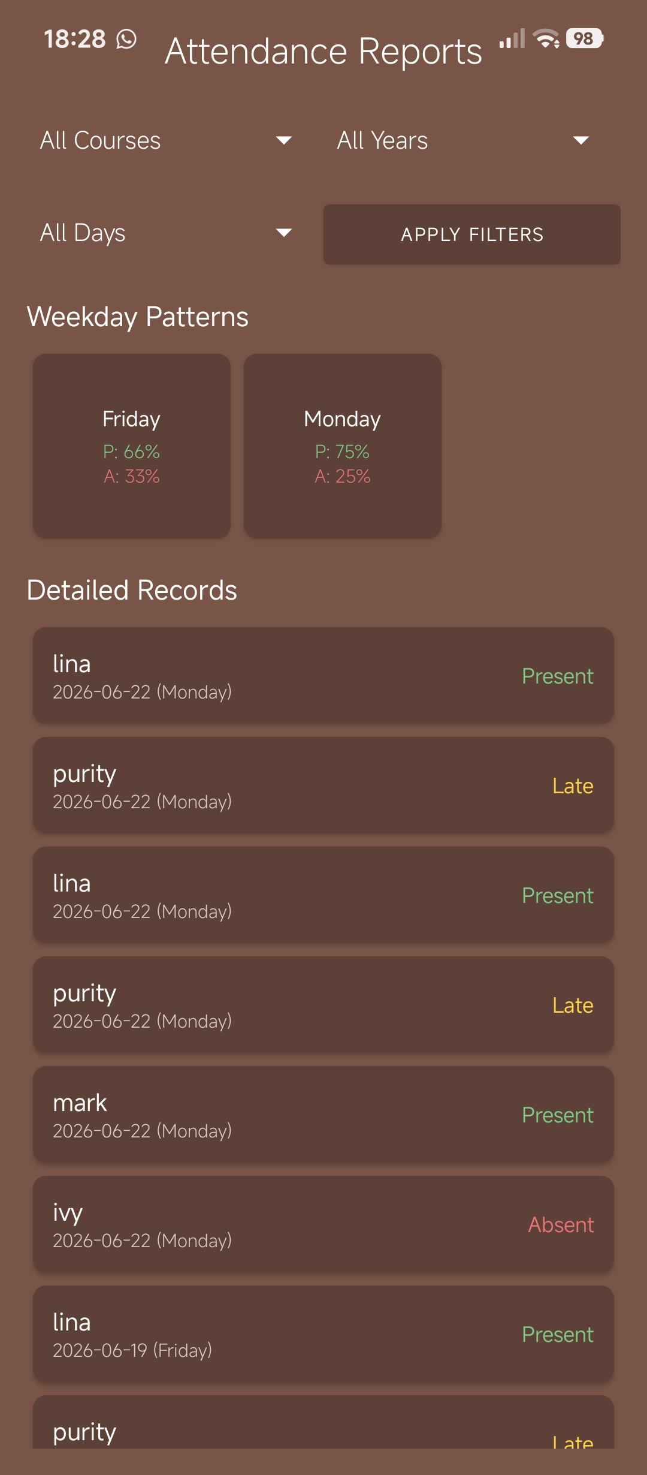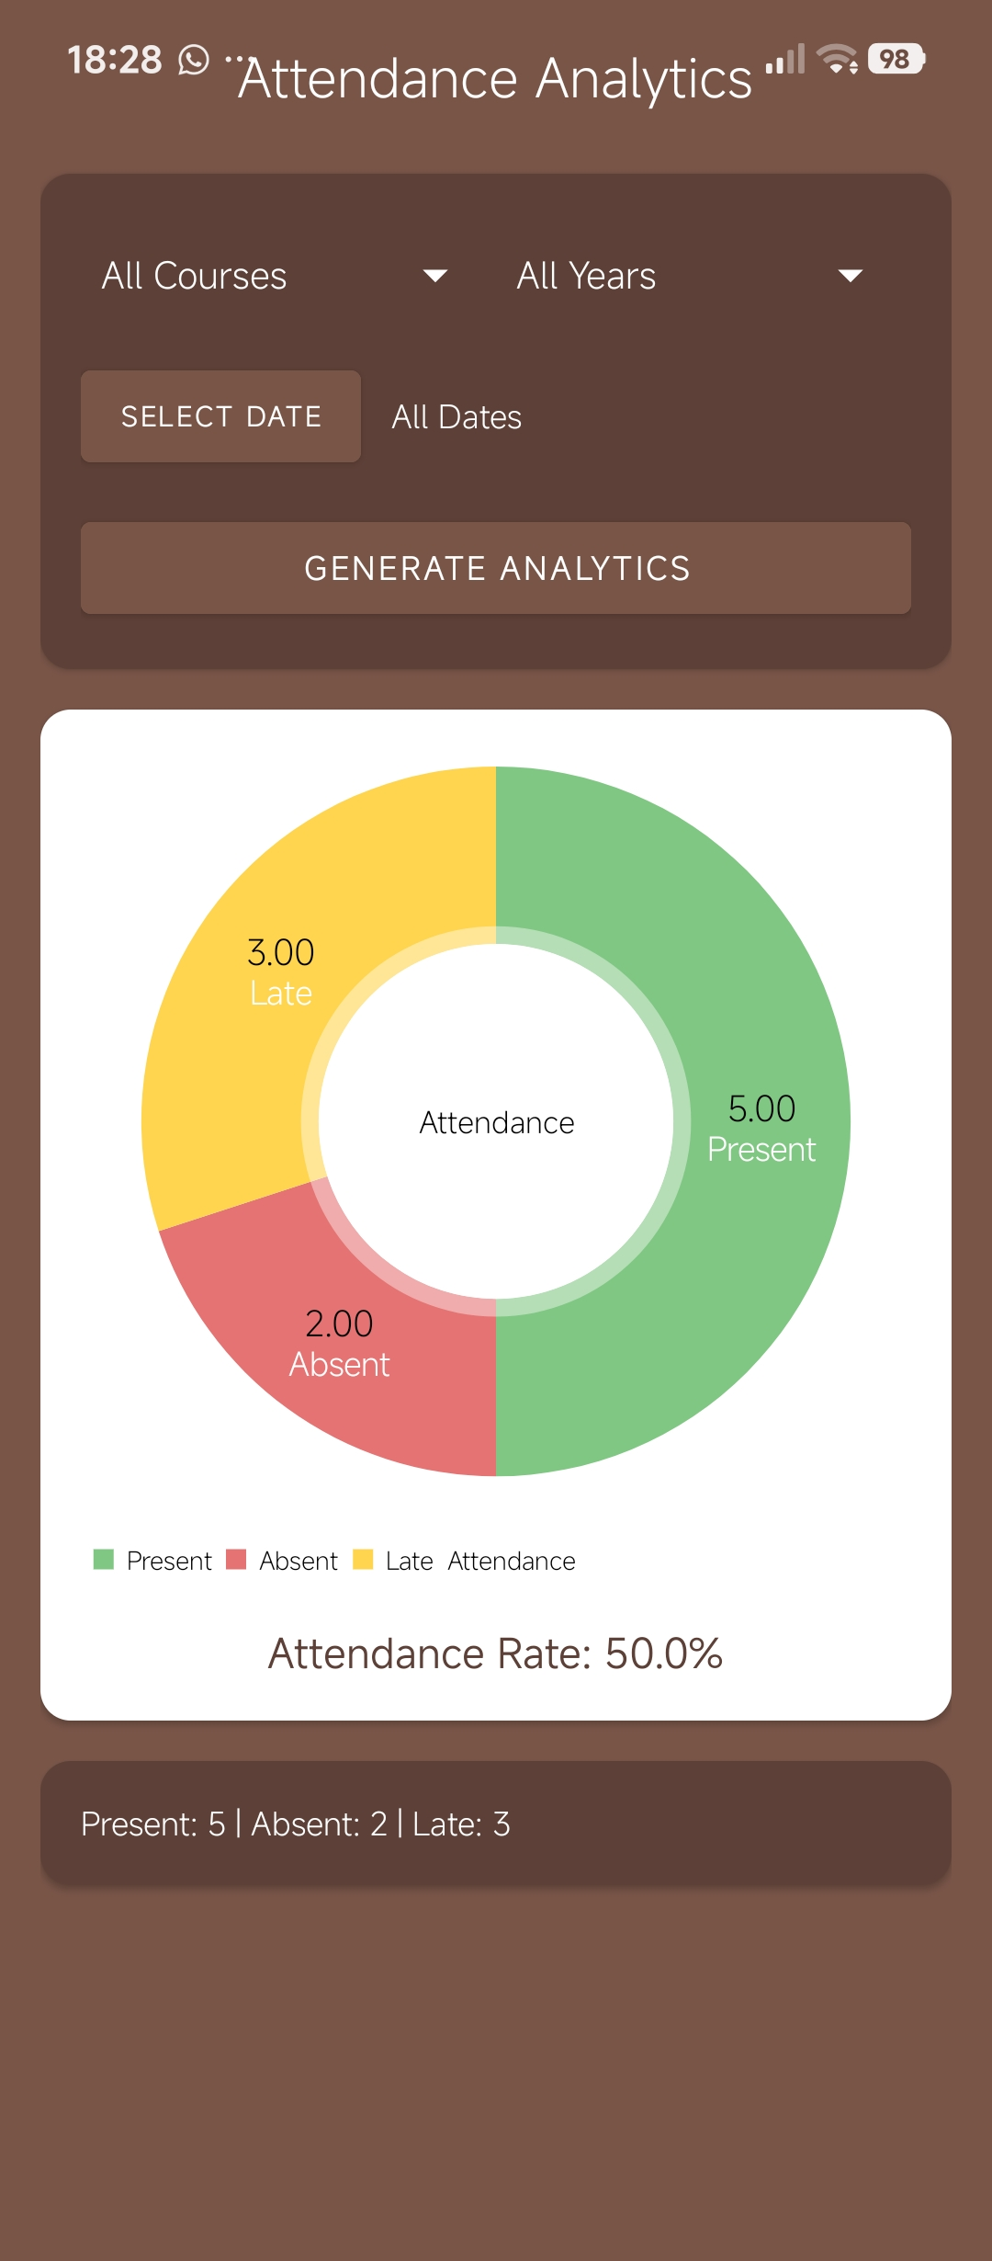
TOOLS USED
- Android studio
- Java
- Kotlin
- Android SDK
- SQlite
Personal reflection
This project enhanced my understanding of mobile data storage, database design, and application development. I learned how to use SQLite, design tables with primary keys and relationships, and implement CRUD operations. The experience improved my problem-solving, database management, and mobile development skills, preparing me for more advanced projects.

Task 1: Storage Method Comparison

1. Shared Preferences

Advantages
- Easy to implement and use.
- Stores small amounts of data efficiently.
- Fast data access and retrieval.
- Suitable for storing login status.
- Suitable for storing user preferences and application settings.

Disadvantages
- Cannot store large amounts of data.
- Not suitable for complex data structures.
- Limited functionality compared to databases.
- Data is stored only on the device.

2. SQLite

Advantages
- Works without an internet connection.
- Lightweight and embedded within the application.
- Supports CRUD (Create, Read, Update, Delete) operations.
- Efficient for storing structured data.
- No separate server is required.

Disadvantages
- Requires knowledge of SQL queries.
- Database management can be complex for large applications.
- Data is stored only on the local device.
- Scaling becomes difficult with large datasets.

3. Firebase

Advantages
- Provides real-time data synchronization.
- Cloud-based storage accessible from anywhere.
- Supports user authentication and security features.
- Easily scalable for large applications.
- Allows data sharing across multiple devices.

Disadvantages
- Most features require an internet connection.
- Costs may increase as application usage grows.
- Dependency on external cloud services.
- Performance may be affected by network issues.

4. Internal Storage

Advantages
- Data is private and secure within the application.
- Works without an internet connection.
- Suitable for storing files such as documents and images.
- No special permissions are usually required.

Disadvantages
- Limited by the device's storage capacity.
- File management can become difficult as data grows.
- Data may be lost if the application is uninstalled.
- Not ideal for sharing data between applications.

Task 2: Student Database Design

Introduction
The purpose of this database is to store and manage student information in a university student management application. The database will keep records of students and make it easier to retrieve, update, and manage their information.

Table Structure
The database contains one table called Students with the following fields:
Field Name | Data Type | Description
StudentID | INTEGER | Unique student identification number
Name | TEXT | Full name of the student
Course | TEXT | Course enrolled by the student
Year | INTEGER | Academic year of study
PhoneNumber | TEXT | Student's phone number

Primary Key
The StudentID field is the Primary Key (PK) because it uniquely identifies each student in the database. No two students can have the same StudentID.

Students Table Design
STUDENTS
StudentID (PK)
Name
Course
Year
PhoneNumber

Sample Data
StudentID | Name | Course | Year | PhoneNumber
101 | John Kamau | BIT | 2 | 0712345678
102 | Mary Wanjiku | BBIT | 3 | 0723456789

SQL Statement for Creating the Table
CREATE TABLE Students (
StudentID INTEGER PRIMARY KEY,
Name TEXT NOT NULL,
Course TEXT NOT NULL,
Year INTEGER NOT NULL,
PhoneNumber TEXT
);

Week 8: Project Planning

Week 9: Device Features and Sensors

Same as week 1

Week 10: Notifications and Background Services

Same as week 1

Week 11: Mobile Security

Same as week 1

Week 12: Testing and Debugging

Same as week 1

Week 13: Application Deployment

Same as week 1

Week 14: Final Project Presentation

Same as week 1

Semester Project Tracking

Project Title

Project Objectives

Project Requirements

Development Milestones

Testing Results

Lessons Learned

Future Improvements

End of Semester Reflection

Summary of Skills Acquired

Most Interesting Topic

Major Challenges Faced

How Challenges Were Overcome

Professional Growth Achieved

Overall Course Experience

Final Approval
Student Name: __________________________
Student Signature: ______________________
Date: _________________________________
Lecturer Name: _________________________
Lecturer Remarks: _____________________
Date: _________________________________

